Logbook 26/08/2026
- Fixed manual input of the GSEA
- Nothing wrong with ORA
- Made the UCell tab, and I am testing it (no output yet)
- 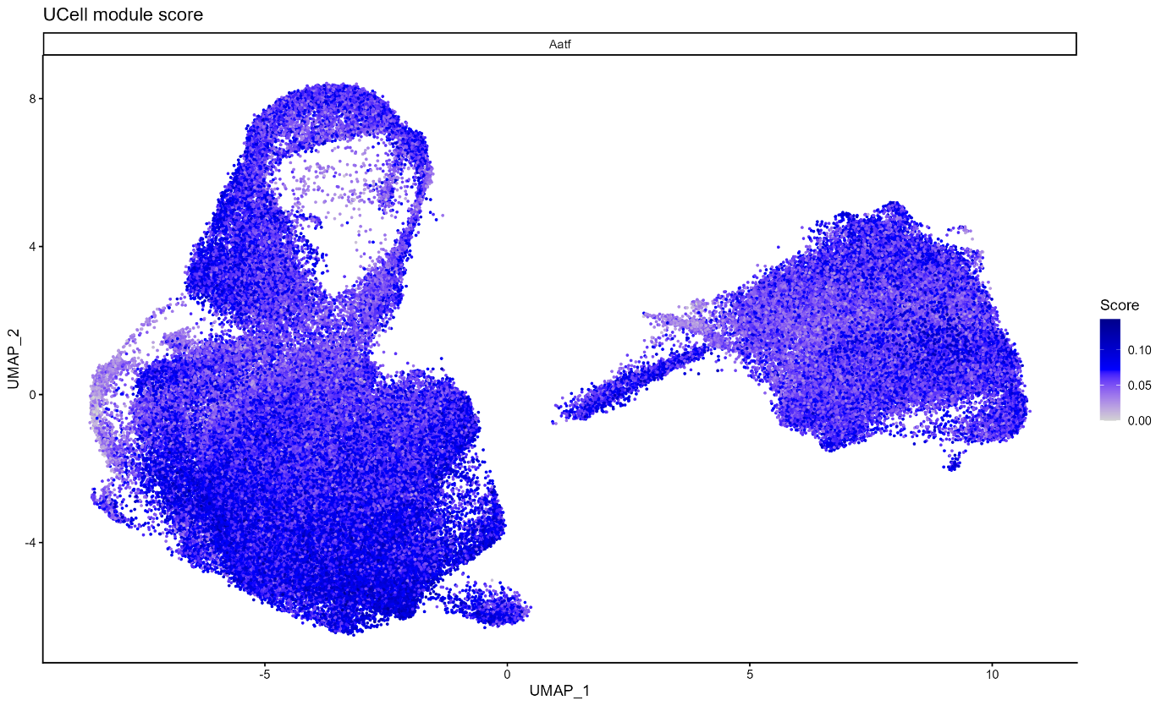
- Aatf (separate scoring per TF, but only Aatf)
- Scoring with precomputed ranks for 4 genes: Serial scoring (cached ranks, clean script): 790.5 sec
- Scoring without precomputed ranks, using data layer, for same 4 genes:

TODO:
- Manual setting GSEA
- UCell tab
- ORA verification

